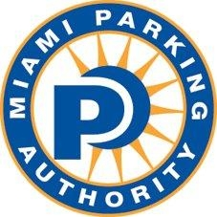

MIAMI PARKING AUTHORITY SETS ASIDE SEVERAL ON-STREET SPACES TO HELP THE COMMUNITY AND URGES DRIVERS TO HEED THESE MEASURES!
(MIAMI, FL – MARCH 19, 2020) – In these challenging times, the well-being, health and need of the Miami community is of our utmost concern. To that end, the Miami Parking Authority (MPA) has set aside a number of on-street spaces in high-demand commercial areas, free of charge, for vehicles picking up and delivering food and other essential items to customers. The program is being rolled out immediately throughout the downtown core, with other commercial areas expected to be added within the next couple of days.
“We are conscious of the impact of the COVID-19 from the human health as well as economic perspectives, and we are asking for the public’s help not to use these dedicated spaces for purposes other than pickups and deliveries,” said Alejandra “Alex” Argudin, Chief Executive Officer. “We stand ready to do everything possible to help the community in the face of this emergency, but we need the public to cooperate with us.”
These free, dedicated spaces are expected to make pickups and deliveries quicker and more efficient, in an effort to help customers, drivers and merchants alike. The on-street spaces will be identified by the signage posted in front of them. Please refer to the attached photo of the on-street signage and check our website periodically at www.miamiparking.com, as we dedicate additional spaces in commercial areas, where restaurants are open for pickup and delivery service.
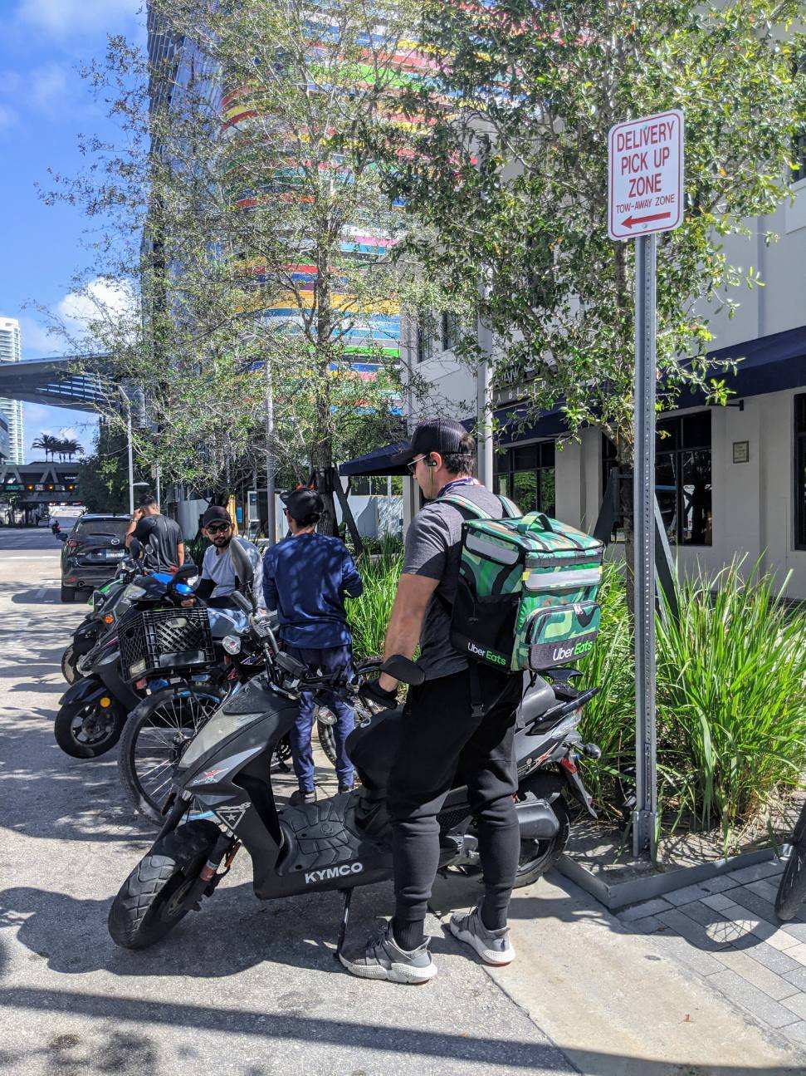

About Miami Parking Authority
Miami Parking Authority, officially known as the Department of Off-Street Parking of the City of Miami, was created in 1955 by a Special Act of the Florida State Legislature and incorporated into the City of Miami's Charter in 1968. MPA manages and develops on- and off-street parking in the City of Miami. It shares responsibility with the City of Miami Police Department and Miami-Dade County for enforcement of parking regulations. For more information, visit www.miamiparking.com.
###
Media Contact: Margarita Rohaidy Delgado, margarita@mrd-consulting.com/305-336-6267.

